

**Heaven's Light is Our Guide**

**RAJSHAHI UNIVERSITY OF ENGINEERING & TECHNOLOGY**

**Department of Computer Science & Engineering**

**Lab Report**

**Course Code :** CSE 1202

**Course Name :** Data Structure Sessional

**Lab No :** 05

**Lab Subject :** Online Judge Problem Solve

**Date of Lab :** 14.08.2023

|  |  |
| --- | --- |
| Submitted by  Name : Tanmoy Mridha  Roll : 2103118  Section : B  Series : 21 | Submitted to  Md. Azmain Yakin Srizon  Lecturer  Department of CSE  RUET |

**Date of Submission:** 28.08.2023

**OJ Problem – 01:**

**Problem Name: Gift Carpet**

**Problem No: 1862** **A**

**Link:** [**https://codeforces.com/contest/1862/problem/A**](https://www.codechef.com/START75D/problems/TWORANGES)

**Code:**

#include <bits/stdc++.h>

using namespace std;

#define ll long long int;

int main(){

int t;

cin >> t;

while(t--){

int n,m, v = 0, i = 0, k = 0 ,a = 0;

cin >> n >> m;

char ar[n][m];

for(int x= 0; x < n; x++){

for(int j= 0; j < m; j++){

cin >> ar[x][j]; } }

for(int j= 0; j < m; j++){

for(int x= 0; x < n; x++){

if(ar[x][j] == 'v' && v == 0){

v++;

break; }

if(v > 0 && ar[x][j] == 'i' && i == 0){

i++; break; }

if(v > 0 && i > 0 && ar[x][j] == 'k' && k == 0){

k++; break; }

if(v > 0 && i > 0 && k > 0 && ar[x][j] == 'a' && a == 0){

a++; break; } } }

if(v >0 && i > 0 && k > 0 && a > 0){

cout << "YES" << endl; }

else

cout << "NO" << endl; } }

**Output:**

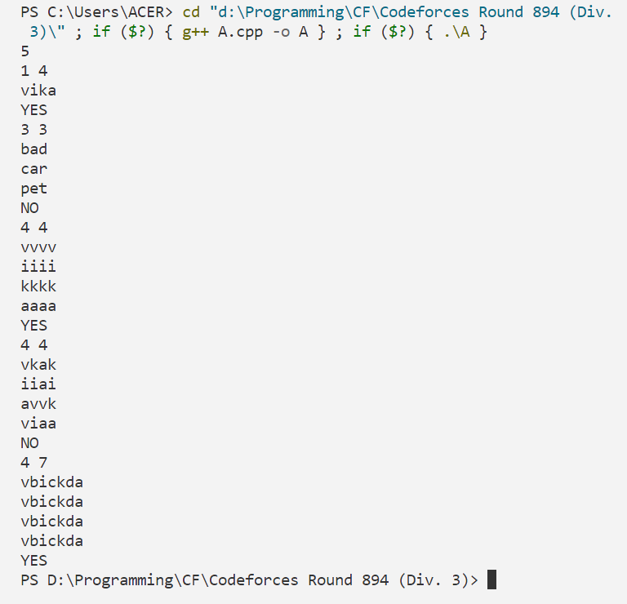

**OJ Problem – 02:**

**Problem Name: Palindromic Numbers**

**Problem No: 1700B**

**Link:** **https://codeforces.com/contest/1700/problem/B**

**Code:**

#include <bits/stdc++.h>

using namespace std;

int main(){

int T;

cin >> T;

while (T--) {

int n;

cin >> n;

string s1, s2, ans;

cin >> s1;

for (int i = 0; i < n; i++) {

s2.push_back('9'); }

if (s1[0] != '9') {

for (int i = 0; i < n; i++) {

s1[i] = ((s2[i]) - (s1[i])) + '0'; }

cout << s1 << endl; }

else {

int c = 0;

for (int i = n - 1; i >= 0; i--) {

int x = s1[i] - '0';

x += c;

if (x > 1) {

int y = 11 - x;

c = 1;

ans += y + '0'; }

else {

int y = 1 - x;

c = 0;

ans += y + '0'; } }

reverse(ans.begin(), ans.end());

cout << ans << endl; } } }

**Output:**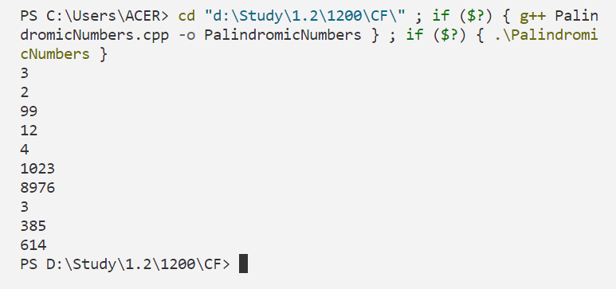

**OJ Problem – 03:**

**Problem Name: Lovely Palindromes**

**Problem No: 688B**

**Link:** **https:** **https://codeforces.com/contest/688/problem/B**

**Code:**

#include <bits/stdc++.h>

using namespace std;

int main(){

string a;

cin >> a;

cout << a;

reverse(a.begin(), a.end());

cout << a << endl;

}

**Output:**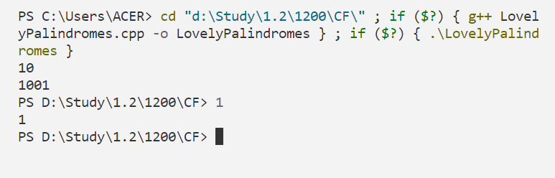

**OJ Problem – 04:**

**Problem Name: Parity Sort**

**Problem No: 1851B**

**Link:** **https:** **https://codeforces.com/contest/1851/problem/B**

**Code:**

#include <bits/stdc++.h>

#define ll long long int

using namespace std;

int main(){

int T;

cin >> T;

while (T--) {

ll n, check = 0;

cin >> n;

ll array[n];

ll array1[n];

for (ll i = 0; i < n; i++) {

cin >> array[i];

array1[i] = array[i]; }

sort(array,array + n);

for (ll i = 0; i < n; i++) {

if(array[i] % 2 != array1[i] %2){

check = 1; } }

if(check){

cout << "NO" <<endl; }

else

cout << "YES" <<endl; } }

**Output:**

